Yorkshire Wassail
1.We've been a -while a wandering
Amongst the leaves so green.
But now we come a wassailing
So plainly to be seen,
For it's Christmas time, when we travel far and near;
May god bless you and send you a happy New Year.
2.
We are not daily beggars
That beg from door to door;
We are your neighbors children,
For we've been here before;
For it's, etc.
4.
Call up the butler of this house,
Likewise the mistress too,
And all the little children
That round the table go;
For it's, etc.
3.
We've got a little purse;
Made of leathern ratchin skin;
We want a little of your money
To line it well within;
For it's, etc.
5.
Bring us out a table
And spread it with a cloth,
Bring us out a mouldy cheese
And some of your Christmas loaf;
For it's, etc.
6.
Good master and good mistress,
While you're sitting by the fire,
Pray think of us poor children
That's wandered in the mire;
For it's, etc.
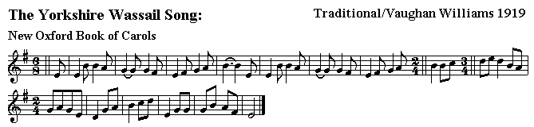

Gloucestershire Wassail
Melody -
Wassail! wassail! all over the town,
Our toast it is white and our ale it is brown;
Our bowl it is made of the white maple treel
With the wassailing bowl, we'll drink to thee.
2. Here's to our horse, and to his right ear,
God send our measter a happy new year:
A happy new year as e'er he did see,
With my wassailing bowl I drink to thee.
3. So here is to Cherry and to his right cheek
Pray God send our master a good piece of beef
And a good piece of beef that may we all see
With the wassailing bowl, we'll drink to thee.
4. Here's to our mare, and to her right eye,
God send our mistress a good Christmas pie;
A good Christmas pie as e'er I did see,
With my wassailing bowl I drink to thee.
5. So here is to Broad Mary and to her broad horn
May God send our master a good crop of corn
And a good crop of corn that may we all see
With the wassailing bowl, we'll drink to thee.
6. And here is to Fillpail and to her left ear
Pray God send our master a happy New Year
And a happy New Year as e'er he did see
With the wassailing bowl, we'll drink to thee.
7. Here's to our cow, and to her long tail,
God send our measter us never may fail
Of a cup of good beer: I pray you draw near,
And our jolly wassail it's then you shall hear.
8. Come butler, come fill us a bowl of the best
Then we hope that your soul in heaven may rest
But if you do draw us a bowl of the small
Then down shall go butler, bowl and all.
9. Be here any maids? I suppose here be some;
Sure they will not let young men stand on the cold stone!
Sing hey O, maids! come trole back the pin,
And the fairest maid in the house let us all in.
10. Then here's to the maid in the lily white smock
Who tripped to the door and slipped back the lock
Who tripped to the door and pulled back the pin
For to let these jolly wassailers in.

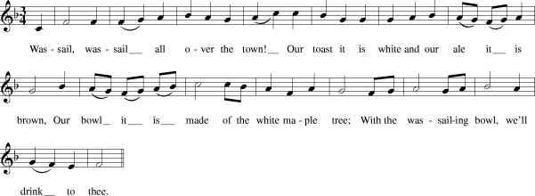

THE TRUNCH WASSAIL SONG
Here we come a wassailing all among the leaves
That isn't very easy when they're still all on the trees
Wassail, wassail, we'll tell you wassail
It comes in bottles brown and pale
Comes in bottles, so bring some here
And we'll have a happy new year
Lets us now be thankful that the old year had departed
But there's no time for feast before another one has started
Chorus
Now the year has past away, past away your sins
There's lots of lovely new ones as the year begins
Chorus
Pouring cider on the apple trees seems rather wrong
We'll drink it first and then we'll water the trees before too long
Chorus
Bring food from off your table and beer from out o' your barrel
For If you don't we'll stop and sing another ancient carol
NotationWritten by Sid and Henry Kipper, Dambuster Re
cords. Recored on "The Ever Decreasing Circle."
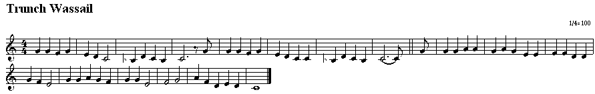

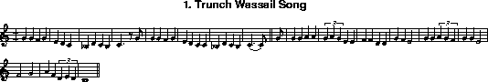

Here we Come A-wassailing
Here we come a-wassailing
Among the leaves so green,
Here we come a wand'ring,
So fair to be seen.
Chorus
Love and joy come to you,
And to your wassail too,
And God bless you and send you a happy new year,
And God send you a happy new year.
We are not daily beggars
Who beg from door to door,
But we are neighbor's children
Whom you have seen before.
Chorus
We have a little purse
Made of ratching leather skin;
We want some of your small change
To line it well within.
Chorus
God bless the Master of this house,
Likewise the Mistress too;
And all the little children
That round the table go.
Chorus
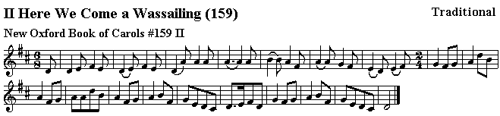

A CARROL FOR A WASSEL-BOWL,
To be sung upon Twelfth-Day at Night, to the tune of " Gallants, come away."
A jolly wassel-bowl,
A wassel of good ale,
Well fare the butler's soul,
That setteth this to sale ;
Our jolly wassel.
Good dame, here at your door
Our wassel we begin,
We are all maidens poor,
We pray now let us in,
With our wassel.
Our wassel we do fill
With apples and with spice,
Then grant us your good will
To taste here once or twice
Of our good wassel.
If any maidens be
Here dwelling in this house.
They kindly will agree
To take a full carouse
Of our wassel.
But here they let us stand
All freezing in the cold :
Good master, give command
To enter and be bold,
With our wassel.
Much joy into this hall
With us is entered in ;
Our master, first of all,
We hope will now begin
Of our wassel.
And after his good wife
Our spiced bowl will try ;
The Lord prolong your life,
Good fortune we espy
For our wassel.
Some bounty from your hands,
Our wassel to maintain:
We '1 buy no house nor lands
With that which we do gain
With our wassel.
This is our merry night
Of choosing king and queen,
Then be it your delight
That something may be seen
In our wassel.
It is a noble part
To bear a liberal mind ;
God bless our master's heart,
For here we comfort find,
With our wassel.
And now we must be gone
To seek out more good cheer,
Where bounty will be shown,
As we have found it here,
With our wassel.
Much joy betide them all,
Our prayers shall be still,
We hope and ever shall,
For this your great good will
To our wassel.
- William Sandys, Christmas Carols, Ancient and Modern: Including the Most Popular in the West of England, and the Airs to which They are Sung. Also Specimens of French Provincial Carols. With an Introduction and Notes,R. Beckley, 1833, p.54-55.
Also in Ritson with this note:
From a collection entitled, " New Christmas Carrols: " Being fit also to be sung at Easter, Whitsuntide, and other Festival days in the year." no date, 12mo. . black letter ; in the curious study of that ever to be respected antiquary Mr. Anthony a Wood, in the Ashmoleian Museum.
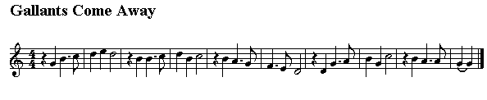

Gower Wassail I
A wassail, a wassail, throughout all the town,
Our cup it is white and our ale it is brown.
CHORUS: Tol-de-rol-lol.
Our wassail it is made of a good ale and cake,
Some nutmeg and ginger, the best we could get.
Our bowl it is made of an elbury bough,
And now, my good master, I'll drink unto thou.
Besides all of that, we have apples in store,
Pray let us come in, for 'tis cold by the door.
We know by the moon that we are not too soon,
We know by the sky that we are not too high.
We know by the stars that we are not too far,
We know by the ground that we are within a sound.
We come on a design for to taste of your ale
Out of that li'l kinter keg that stands next to the wall
Now master and mistress, if you are within,
Pray send out your maid with a lily white skin
To open the door without more delay
Our time it is precious and we cannot stay.
You have brought us your wassail, that's very well known.
But we can assure you we've as good of our own.
And as for your wassail, we care not a pin
But for your good company you shall come in.
Now master and mistress, thanks to you we'll give
And for our jolly wassail, as long as we live.
Here's a health to Old Colley, with her crooked horn,
Pray God send our master a good crop of corn.
Both barley and oats, and all sorts of grain,
Pray God send our master a long life to reign.
And if we should live 'til another New Year,
Perhaps we may come and see who do live here.
- The earliest version of the Gower Wassail? The Wassail Song in Reverend J D Davies' A History Of West Gower, 1884.
(it is noted that it was sung on New Year's Eve.)

GOWER WASSAIL II
A-wassail, a-wassail throughout of this town
Our cup it is white and our ale it is brown
Our wassail is made of good ale and cake
Of nutmeg and ginger, the best we can bake
Al dal di dal di dal
Dal di dal di dal
Dal di dal di dee
Sing deero, sing daddy
Sing too ral di do
Our wassail is made of the el'berry bough
Although my good neighbors I'll drink unto thou
Besides all on earth, we have apples to store
Pray let us come in for its cold by the door
We know by the moon that we are not too soon
And we know by the sky that we are not too high
We know by the star that we are not too far
And we know by the ground that we are within sound
Now master and mistress let your company forbear
To fill up are wassail with you cider and beer
We want none of your pale beer, nor none of your small
But a drop of your kilderkin, that's next to the wall
Now master and mistress if you are within
Pray send out your maid with her lily-white skin
For to open the door without more delay
For our time it is precious and we cannot stay
You've brought your wassail, which is very well known
But I can assure you we've as good of our own
As for your jolly wassail, we care not one pin
But its for your good company we'll let you come in
Here's a health to our Cooley and her croo'ed horn
May God send her Master a good crop of corn
Of barley and wheat and all sorts of grain
May God send her Mistress a long life to reign
Now Master and Mistress, know you will give
Unto our jolly wassail as long as you live
And if we do life to another new year
We'll call in again just to see who lives here
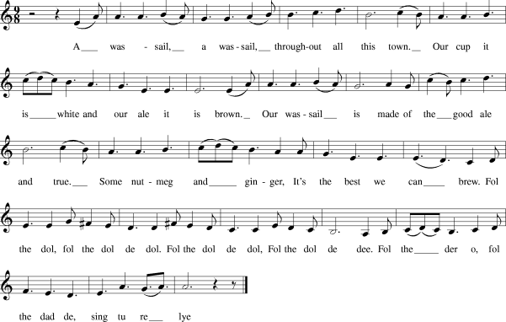

SOMERSET WASSAIL
Wassail and wassail all over the town
The cup it is white and the ale it is brown
The cup it is made of the good ashen tree
And so is the malt of the best barley
For its your wassail and its our wassail
And its joy be to you and a jolly wassail
Oh master and missus, are you all within?
Pray open the door and let us come in
O master and missus a-sitting by the fire
Pray think on us poor travelers, a traveling in the mire
Oh where is the maid with the silver-headed pin
To open the door and let us come in
Oh master and missus, it is our desire
A good loaf and cheese and a toast by the fire
There was an old man and he had an old cow
And how for to keep her he didn't know how
He built up a barn for to keep his cow warm
And a drop or two of cider will do us no harm
The girt dog of Langport he burnt his long tail
And this is the night we go singing wassail
O master and missus now we must be gone
God bless all in this house until we do come again
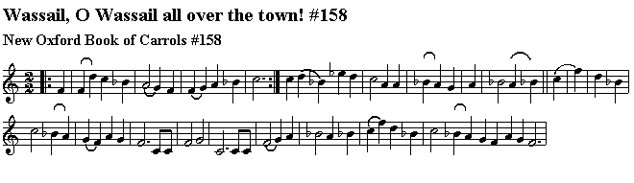
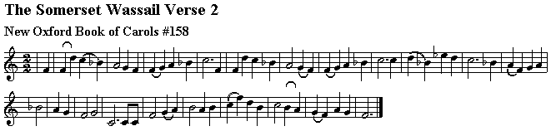
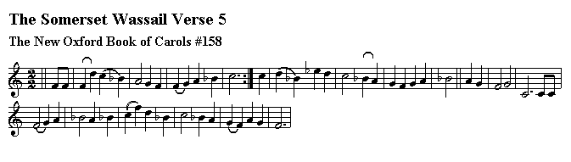

9. A Mummer’s Play

Sussex Tipteerers' Play

Introduction: In connection with the celebration of Christmas in Sussex, a rude outdoor play is still performed on Boxing Day (St. Stephen's Day) . ….I am now able to give the full text of a very complete version, with full explanatory notes….The origin of the name Tipteers or Tipteerers, as the Sussex mummers are termed, appears to be obscure, unless it is derived from their obtaining "tips" in recompense for their performance.

The play is probably a corruption of "The Seven Champions of Christendom”…..”As regards costume, Mr. Young writes:--"Glazed calico of decidedly pronounced colours, with a sprinkling of spangles and ribbon, formed the basis. The Turk was, when I last saw the show, the best dressed as regarded nationality, with short skirt, very baggy trousers, and an impromptu turban. The prevailing sword was an ingenious arrangement of laths. Their stage was "the Queen's highway."….

Dramatis Personae.
Father Christmas
St. George
Noble Captain.
Turkish Knight
Valliant Soldier.
Bold Prince (a fancy character).
Doctor.
Prince of Peace.
Little Johnny Jack

Enter Father Christmas

Father Christmas: In comes I, Old Father Christmas, Am I welcome or am I not? Sometimes I am cold, sometimes I am hot,(One Sussex version of the play adds here, "Sometimes sober and sometimes not," and this is doubtless not unfrequently the case with the performer.) I hope that Old Father Christmas will never be forgot. Room, ladies and gentlemen, room I pray, While I lead St. George and all his noble men this way. Walk in St. George and act thy part, And shew the ladies and gentlemen thy valiant art. Walk in, St. George

Enter St George.

St. George: In comes I St. George, That man of courage bold; With my sword and shield I have won ten thousands of gold. I fought the fiery Dragon, and brought him to great slaughter, And by that means I gained the King of Egypt's daughter.

Father Christmas: Walk in, you Noble Captain.

Enter Noble Captain.

Noble Captain: In comes I the Noble Captain, Possibly this character represents St. Denis.) lately come from France; With my broad sword and jolly Turk I'll make St. George to dance.

St George: Neither to you I am bound to bend.

Noble Captain: Why, sir, did ever I take you to be my friend?

St. George: Yes, you saucy coxcomb.

Noble Captain: Coxcomb is a glorious name.

St. George: You are right to be stabbed.

Noble Captain: To be stabbed, sir, is the least I fear.

St. George: Appoint a place and I'll meet you there.

Noble Captain: The place is appointed on this ground, Where I mean to lay thy body down.

St. George: I will cross the water that is so wide.

Noble Captain: Done, sir, I'll meet you there if I am alive, I will cross the water with our ten, I will meet you there with ten thousand men.

St. George: I'll cut, I'll slay you, I'll let you know I am St. George the Briton oh.

Noble Captain: I will cross the water with our four, And meet you there with ten thousand more. Oh, St. George, hold thy hand, While I send in my Turkish man. Walk in, you Turkish Knight.

Enter Turkish Knight.

Turkish Knight: In comes I the Turkish Knight, Come from the Turkish land to fight. I will fight St. George, that man of courage bold; If his blood is hot I will quickly make it cold.

St. George: Oh Turk, oh Turk, do not boast, Or I will cut you down as small as dust.

Turkish Knight: Oh, St George, do not threaten, Or I will cut you down with my rusty old weapon.
St. George: Oh Turk, oh Turk, do not caper, Or I will cut you down with my old rapier.

(They fight and St. George falls slightly wounded.)

Father Christmas: Arise, St. George, and do not refrain, But boldly rise, and fight that dreadful Turk again.

(St. George rises and fights Turk again.)

Turkish Knight: (on one knee). Down on my bending knee, A poor Turkish slave, I crave to thee.

St George.: Get up, you Turkish Knight, Go home to your Turkish land and fight; Go home and tell them what champions there is in Old England dwells. I will send in my Valiant Soldier.

Father Christmas: Walk in, you Valiant Soldier.

Enter Valiant Soldier.

Valiant Soldier: In comes I the Valiant Soldier, Bold Slasher is my name, My head is crowned in iron, (A helmet,) My body is cased in steel, (Armour) And with my sword into my knuckle-bone I will fight this Turk all in this field; I will pull out my sword and fight, pull out my purse and pay, For satisfaction will I have before I go away.

Turkish Knight: No satisfaction shall you have, No satisfaction will I give, For in a moment's time, you rascal, I will bring you to your silent grave.
Valiant Soldier: I have traveled England, Ireland, Scotland, France, Spain, and Wales, for what St. George shall have his will, You Turkish dog I soon will kill.

Enter Bold Prince

Bold Prince: In comes I Bold Prince, with spear in hand, Bid thee fly foes to fear not. Stand, Stand St. George, that great man of command, The ruler over the British land, Advance the power this very hour; Gallant sons you must obey, Let fly your hands, and fight on my lads, with a good huzza! Hooray! Fierce fight, Turk Killed )
There, ladies and gentlemen, see what I have done, I have cut him down like the evening sun.

Noble Captain: Oh fie! oh fie! my man is slain, And on this ground his body laid; Oh, for some doctor I must seek While my man lies bleeding here so deep. Oh doctor, doctor! come with speed To heal the sick, and raise the dead: Oh, is there a doctor to be found to raise this dead man from the ground?

Father Christmas: Oh, yes, here's a doctor well and good, With my hand I am endeavouring to stop the blood; Stop the blood, and heal the wound, And raise that dead man from the ground.

Enter Doctor

Father Christmas: Well, Doctor, what can you cure?

Doctor: Cure the hipsy, pipsy, palsy pains, and the gout, All raging pains both in and out, A broken leg, or a broken arm; And if that man's neck was broke I'll be bound to put it together again, Or else I would not charge you one farthing to be paid.

Noble Captain: Well, Doctor, what's your fees?
Doctor: My fee is nineteen pounds nineteen shillings and eleven pence three farthings, And half that money I demand to-day.

Noble Captain: Stop, Doctor, stop! I will pay you in the morning.

Doctor: Morning? what's the morning to do with me? I will take my horse and be gone.

Noble Captain: Stop, Doctor, stop! here's an ass for you to ride.

Doctor: An ass! go ride your ass yourself; A horse I rode here, and a horse I will ride away.

Noble Captain: Here; stop, Doctor, stop! Ill pay you in the evening.

Doctor: Now you talk something like a man.

Noble Captain: Well, Doctor, try your skill.

Doctor: Well, I have a small box of pills by my side called the Junpers; I have also a small bottle of drops called the Golden Gloster Drops; I'll put one drop on his temple, one on his nose, Put a pill in his mouth, and strike a light all over his body. Why you see he begins to move already. (Turk revives.)

Noble Captain: Arise, young man, and try to stand, And see how gently you can walk.

Doctor: And now all for your Noble Captain I have cured your man, I am one of the sons of the seventh son, (The healing powers of a seventh son are well known. See: Folk-Medicine. (W.G. Black), pp. 136,137, &c. The writer's brother, Frank J. Sawyer (of New College, Oxford), is a seventh son, and when a child, it was often remarked by Sussex friends that "he was born to be a doctor." The prognostic has been fulfilled in a singular way by his recently graduating as Dorctor of Music!

Born in High Germany. I am not one of these runabout doctors. What I do, I do plainly before your face, And if you can't believe that, it is a very hard case.

Enter the Prince of Peace.

Prince of Peace: In comes I the Prince of Peace: The very first year that I was born, A cruel Russian war begun (This allusion is obscure) Peace! ladies and gentlemen, peace! I call, For I am come to save you all. Ladies and gentlemen, let your voices ring, Clap your hand together, and let us all sing.

Enter Johnny Jack

Johnny Jack: In comes I little Johnny Jack, (In some place the Christmas mummers are called "Johnny-Jacks.") With my wife and family at my back. Money I want, money I crave, If you don't give me that I wish you in your grave.

_______________________________

Mr. Young says the last character "did not occur in the regular "mum," but was added to draw coin." He further remarks: ' In reference to the "Prince of Peace," I think I recollect reading that it was not uncommon to introduce sacred personages by way of moral into these outdoor plays, such as are still represented on the Continent in "Passion Plays." "….It will be seen on comparison that the Sussex play resembles in outline the Hampshire "Christmas Mystery," published in Notes and Queries,, Second series, xii, 493. In the Sompting version (kindly sent by Mrs. Pullen-Burry, of Rectory House, Sompting, Sussex) St. George, after referring to "having won the King of Egypt's daughter, " goes on to say:-

Therefore if any man dare to enter this place,
I will cut him and hack him as small as dust;
And afterwards send him to a cook's shop
To be made into mince-pie-crust."

The conclusion of the Sompting version:
Johnny Jack: My family is large, but I am small, So every little helps us all. So ladies and gentlemen, just at your ease, Put your hands in your pockets And give the poor little Christmas boys just what you please."

A third version is cited (rom a Brighton Tipteerer):

In comes I the little Sweep,
All the money I gets I keep;
In my pockets bread and cheese,
Ladies and gentlemen, give me what you please
Christmas comes but once a year,
But when it comes it brings good cheer:
Roast beef, plum pudding, and mince-pie,
No one likes it better than I.
Ladies and gentlemen,
I wish you a merry Christmas
And a happy new year;
Not forgetting old Father Christmas
And the merry Tipteers."

-Source: Sawyer, Frederick E., ""Tipteerers" Play"., In: The Folk-Lore Journal, Vol. 2, No. 1., January, 1884, pp. 1-8.

