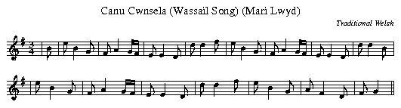

Canu Cwnsela
(Mari Lwyd)=Blessed Mary  Wel,dyma nin dwad  Gyfeillion diniwad,  Wel, dym nin dwad,  Gyfeillion diniwad,  I ofyn cawn gennad,  I ofyn cawn genad, I  I ofyn cawn gennad I ganu  (Ateb)  Rhoweh glywed wyr dothion,  Pa faint ych o ddynion,  A pheth yn wch union  Yw'ch enwau?  (Mai Lwyd)  Os na chawn ni gennad  Rhowch glywed ar ganiad  Pa fodd mae'r 'madawiad  Nos heno.  (Ateb)  Does gen i ddim cinio  Nac arian i'w gwario  I wenud i chwi roeso  Nos heno | See, here be we coming  Six mummers a-mumming  To sing, if becoming,  Our carol  Good luck to your labours  Your pipes and your tabors;  But first tell me, neighbours,  Who be you?  In song you must quell us,  Good fellow, or tell us  How you can compel us  To leave you!  Then Stay; but I fear, Sirs  You'll never find help here, Sirs,  Or money or beer, Sirs,  To cheer you  -English Metrical version/Sir H.I. Bell, From "Old Welsh Folk-Songs"
-Source=Caneuon Traddodiadol Y Cymry (Traditional Songs of the Welsh)., W.S. Gwynn Williams, Gwynn, LLangollen,N.Wales,1961.
"Carol or penillion sung at Christmas-tide in Gwent and Morganwg, in the old pastime called "Mari Lwyd". LLangollen (Eisteddfod) MS (1858). It was understood that the carol singers could demand food and liquor at any house where one of the inmates could not answer each of their stanzas with another. "This type of song was common all over Wales. There is a large collection of the Anglesey ones in the British Museum. "Mari Lwyd" was merely a S. Wales variant of a custom common throughout the country."-J.H. Davies (J.W.E.S.S., Vol.1,Part 1(1909 No.9)
Also may be known as: Y Wassael (As soung by Iona on Nutmeg and Ginger)

